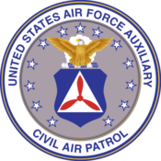 | Nighthawk Squadron Newsletter-Civil Air Patrol
June 2013 | Volume 4, Number 1
In This Issue  - Rocketry Program  - Four Cadets Solo  - Fill the Boot  - June Promotions  - Upcoming Encampment  Cadet Weekly Meeting Schedule Nighthawk Composite Squadron  Week 1-PT-Wear Squadron T-shirt and Black shorts  Week 2-Emergency Services Wear BDU’s  Week 3-Character Development/Leadership Wear Blues  Week 4- Aerospace Education-Wear BDU’s  Week 5- Cadets’ Choice night  Dates to Remember:  TXWG Gliding Academy  July 4th-14th  Rifle Shooting  July 27th  Executive Staff:  Commander:  Cadet 1st Lt. Katy Welch  Deputy Commander:  1st Lt. Jordan Caldwell  Executive Officer:  C/CMSgt Peter Hansen  PANCO Contact Information: austin@thelangleys.net or at 210-315-9717  Public Affairs NCO  Austin Langley, C/SMSgt  Important Sites  To view websites hold Ctrl and click on the links.  - Squadron  - Texas Wing  - Texas Cadet Activity’s | Rocketry Program  Recently Nighthawk Composite Squadron held its annual rocketry program. 11 cadets spent a period of three days building and launching five different rockets. Three of which had motors. On June 15th, cadets launched their rockets that they had learned about the week before in class room instruction time. All of the cadets involved got their rocketry badge, which is highly valuable to them for all of the hard work they put in. The cadets had to take three comprehensive tests on the history and science of rockets.  The cadets also got to have a great time launching their rockets. Most were successful and even the ones that didn’t fly were not a waste. All of the people who helped staff this event (senior members Dragoo and Woolfolk, as well as Mrs. Milbitz and Mr. Tutton) did a wonderful job. This program could not have been successful without them.  In the Civil Air Patrol, rocketry and aerospace are very important. Our squadron is actively gliding, flying, and doing cool projects involved with aerospace. Nighthawk holds a very good glider program. Nighthawk is truly the “eyes over Texas”.  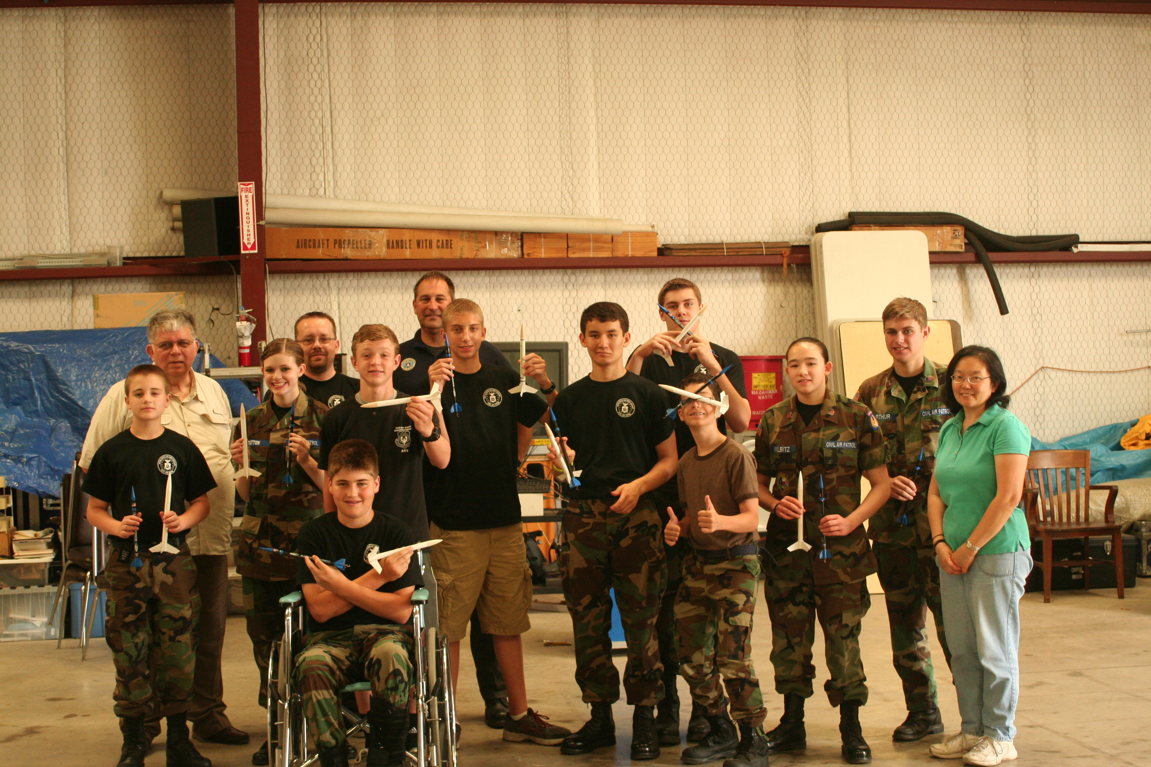  Here are all of the participants at the rocketry program. This was taken at the squadron.  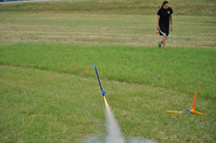  A rocket being launched.  Four Cadets Solo  Four cadets from the Nighthawk Composite Squadron in Denton soloed in a Cessna within a week of each other in June. Cadets Preston Hansen, Katy Welch, Dakota Sellers, and Austin Grant all had similar amazing experiences. After hours of instruction the cadets went up by themselves. Cadets Hansen, Welch and Sellers went to the Texas Powered Flight Academy. Austin Grant soloed in a Cessna through a local flight training program and then soloed in a Blanik glider at the New Mexico CAP Glider Academy a few weeks later. This is a major accomplishment to have four cadets from the same squadron not only get their wings, but at a National Cadet Special Activity as well. This really shows just how hard and devoted the members at Nighthawk are.  C/TSgt Preston Hansen said, “My instructor was named Zulu. Zulu taught me everything I needed to know about flying an aircraft. He was a very quiet guy but was very serious about us understanding how to fly. He gave me the call sign “flaps" because I would always forget to put 20 degrees of flaps down on final. I ended up being the fourth to solo. Zulu had me do three safe landings and take offs without him touching or saying anything and then he taxied off the runway and got out and told me to solo. I was really surprised that he had me solo so quickly; I guess to keep the flying fresh in my head. I ended up having a great solo when it came down to the experience. The one thing I will always remember is that when I was on base about to turn final, I asked myself “am I high, low, fast or slow". This saved my landings a few times actually and it reminded me to adjust one of those things to make a better landing. The ceremony (I had) when Zulu cut off my shirt was unreal. It was such an amazing experience that I will remember for the rest of my life. I would highly recommend any cadet that is thinking about flying as a potential career to attend this academy.”  “All of Nighthawks cadets had a great time” C/1st Lt. Welch said. “My experience at the Powered Flight Academy was good. I had 10.7 hours of flight time by the end of the week. It was very tiring, since I flew about two to three hours a day. The instructors were very good and had a lot of patience so we could solo in a week if we wanted to.” Nighthawk is truly advancing our involvement throughout the region.  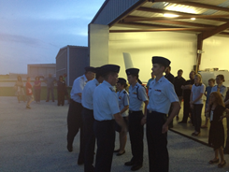  Here are the cadets as they get their wings pinned on. All of them worked very hard to earn them.  Fill the Boot  Recently Nighthawk Composite Squadron held its semiannual Fill the Boot Fundraiser at the Golden Triangle Mall in Denton Texas. The Cadets raised $1700 for the squadron and for their activity’s. Nighthawk worked hard for two days to earn all of these donations. Cadets who participated each got $50 per day to use on cap activities. The activity was fun and really helped our squadron. Be ready for next Winter in which there will be another fill the boot.  June Promotions  Cadet Wilson to Staff Sergeant.  Cadet Alberts to Chief.  Cadet Farquhar to Airman First Class.  Cadet Morris to Senior Airman.  Cadets Dragoo and Block to Technical Sergeant.  Cadet Woods to Master Sergeant.  Cadet Welch completed her PAO achievement.

