Civil Air Patrol
Nighthawk Composite Squadron TX – 413
A Guide on How to Enter a SQTR TASK
This guide will show TX-413 members how to log onto CAP E-Services and enter completed tasks into SQTRs
Let’s get started!
Access E-services by going to: www.capnhq.gov . Log on with your CAPID and password. You should see the screen below.
Step 1: Scroll down and click on the “My Operations Qualifications” link under CAP Utilities on the left of the E-Services homepage.
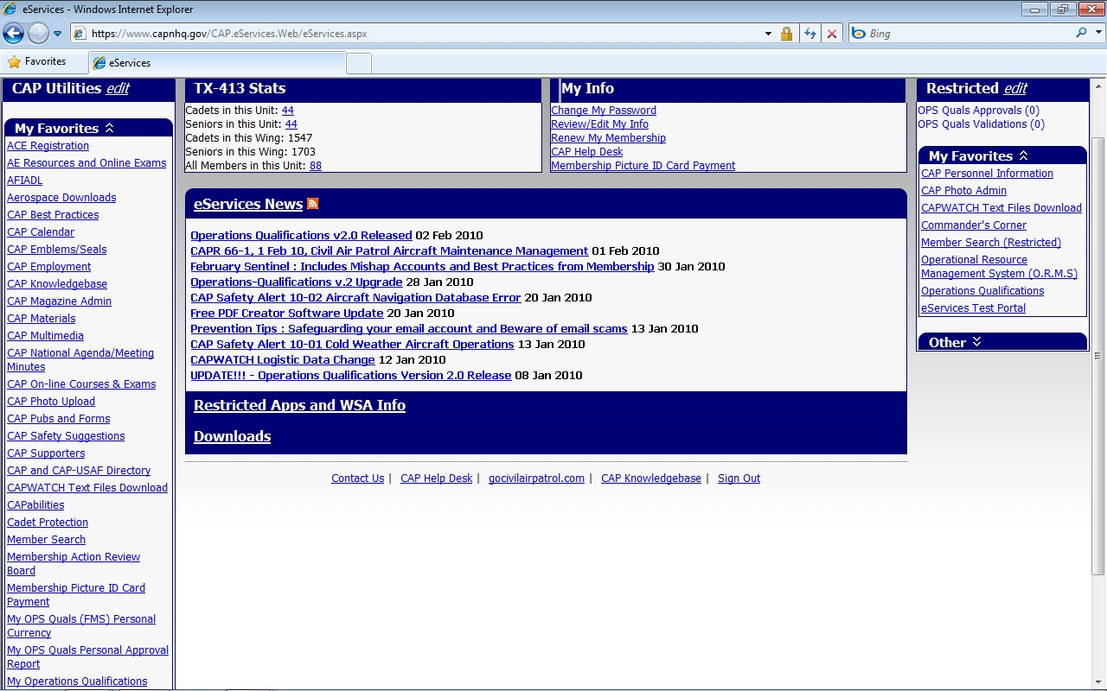

Step 2: Click here to access the Emergency Services SQTR Entry Single Entry page
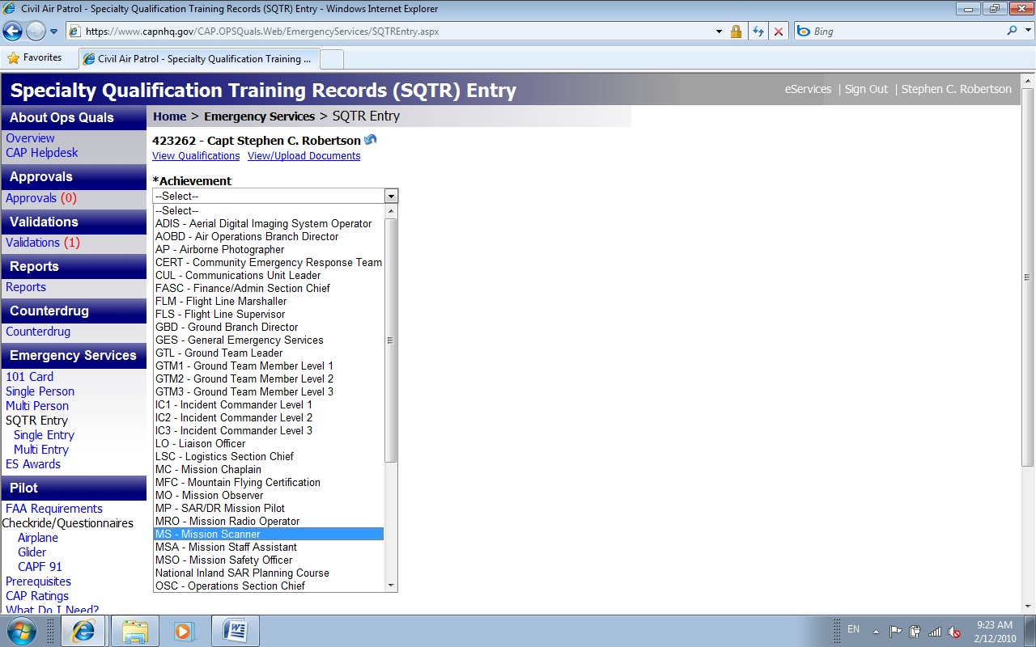
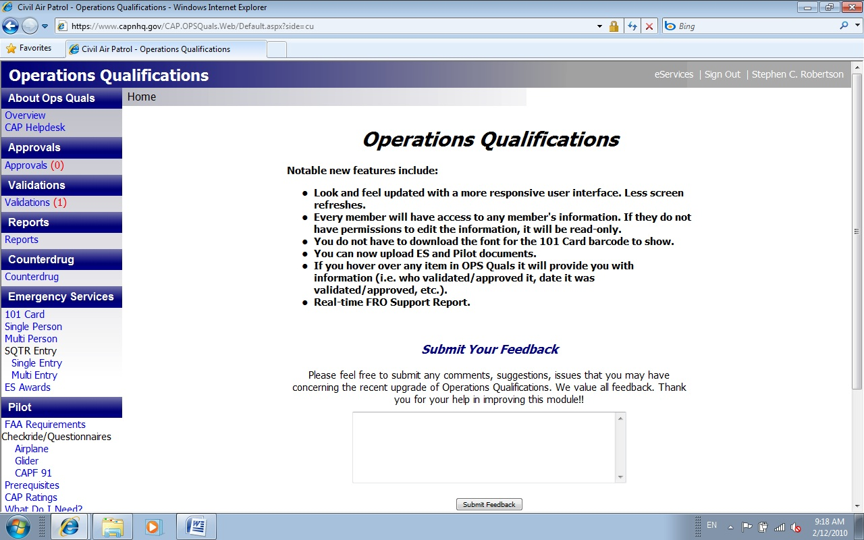
Step 3: Click on the ACHIEVEMENT drop down box and select a SQTR

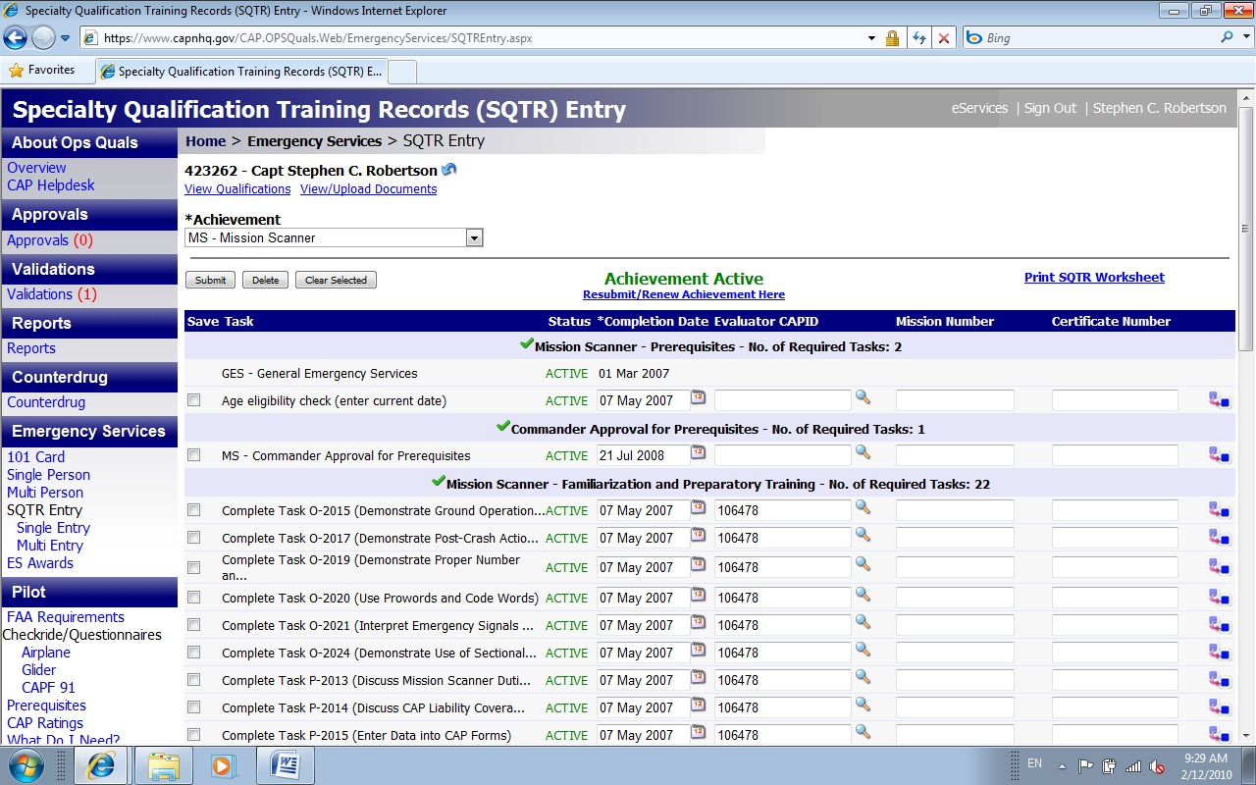
Step 4 Click the box for each task completed
Step 5 Enter date task was completed, evaluator’s CAPID , and Mission No. if there is one
Step 6 Click here to populate all checked boxes with the info
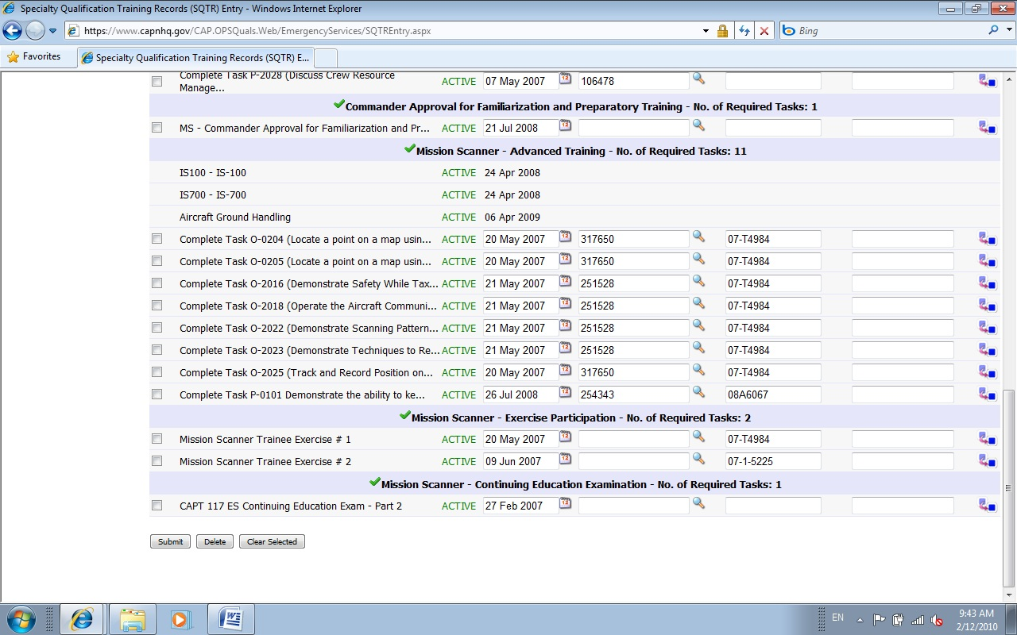

Step 7 Click Submit

Click here to Print your SQTR Worksheet
Click here to Upload documents

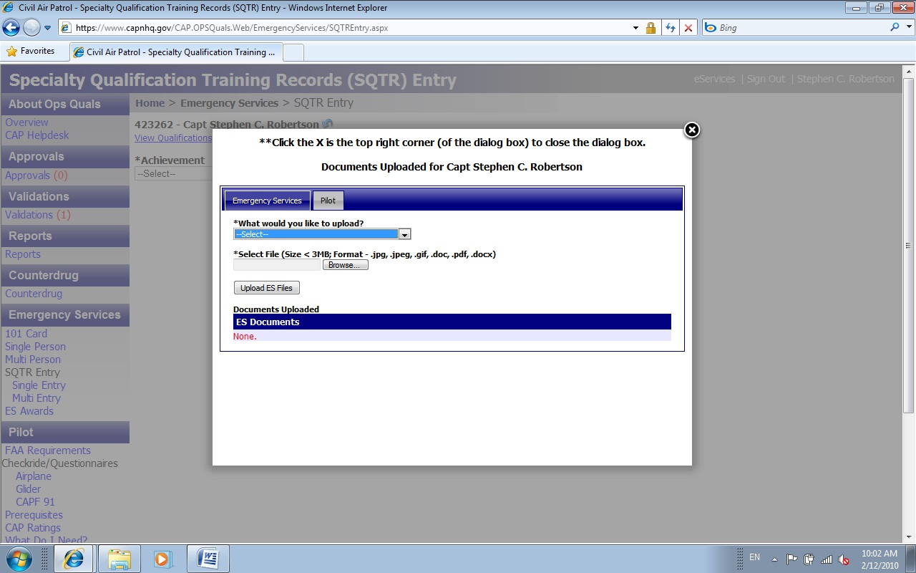
Select the function the document supports, browse your computer for the file and select it, click upload

Step 7 Click Submit

